

Samsung B200

Description
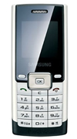
Samsung B200 measures 104 x 44.5 x 16 millimeters, weighs about 80 grams and comes in a classic candybar form factor. The phone features a 1.5 inch CSTN display with 128 x 128 pixels and 65K colors

STORE PRICE: Rs 2,019 /-
ONLINE PRICE: Rs 1,961 /-

Brand : Samsung
Model Name : B200
Released Year : 2008
Phone Memory : 2 MB built-in memory
External Memory : No
Colors : Silver
Form : Bar
Dimensions : 104 x 44.5 x 16 mm
Weight : N/A

